# CS 255 System Design Document

This template lays out all the different sections that you need to complete for Project Two. Each section has guidance to prompt your thinking. You will need to continually reference the interview transcript as you work to make sure that you are addressing your client’s needs. There is no required length for the final document. Instead the goal is to complete each section based on what your client’s needs are. Remove this note when you are finished, and replace all bracketed text with the relevant information.

## UML Diagrams

### UML Use Case Diagram

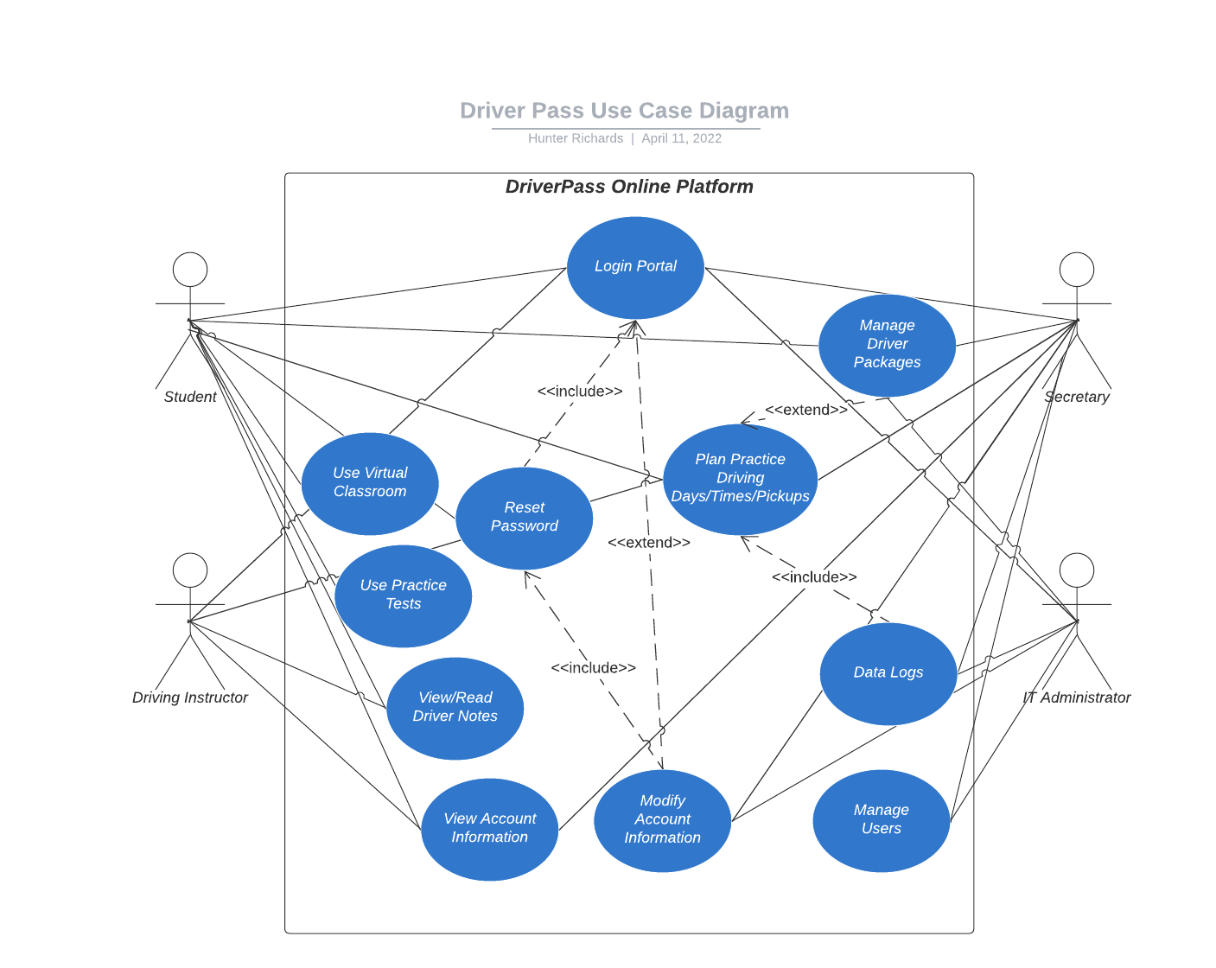

**UML Activity Diagrams**

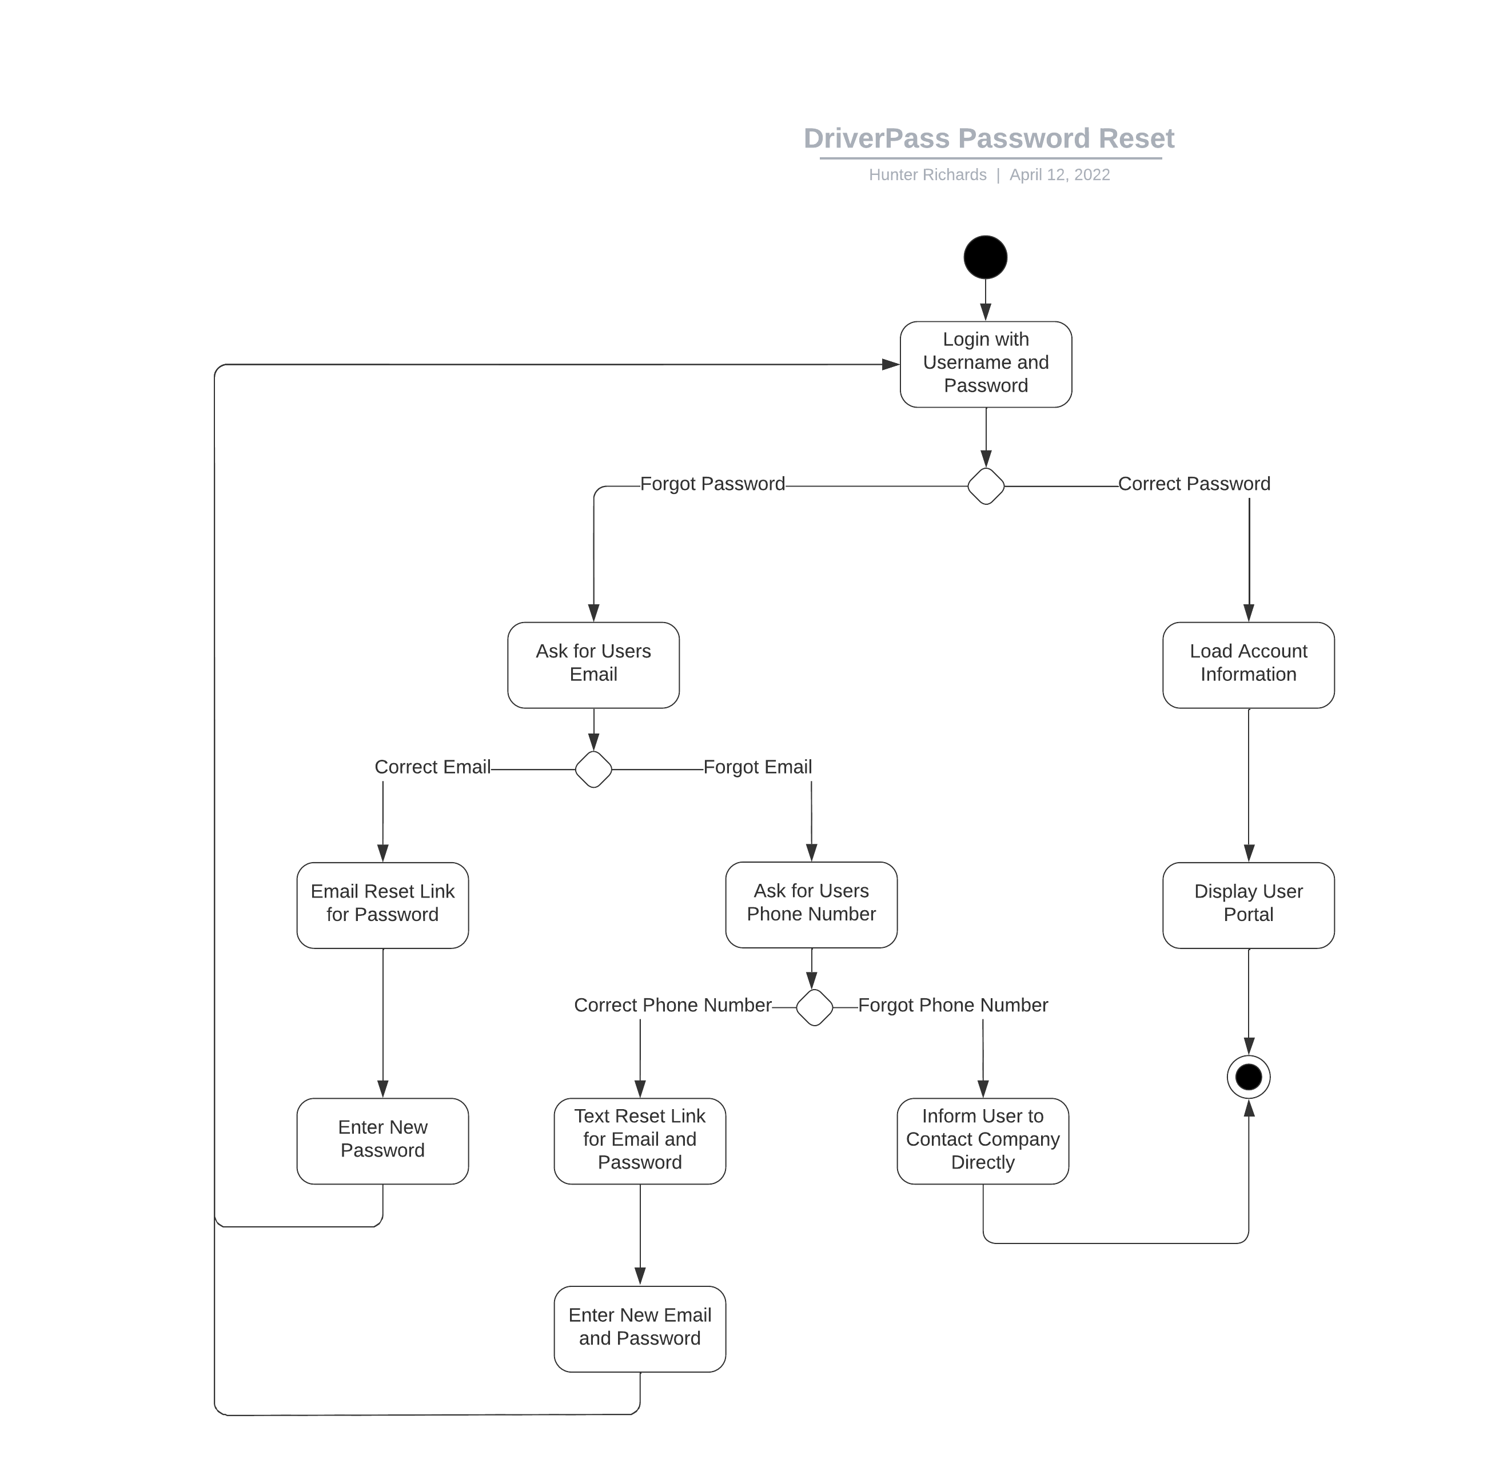

### *C:\Users\Mr_Richards_\Downloads\DriverPass Practice Test.png*

### UML Sequence Diagram

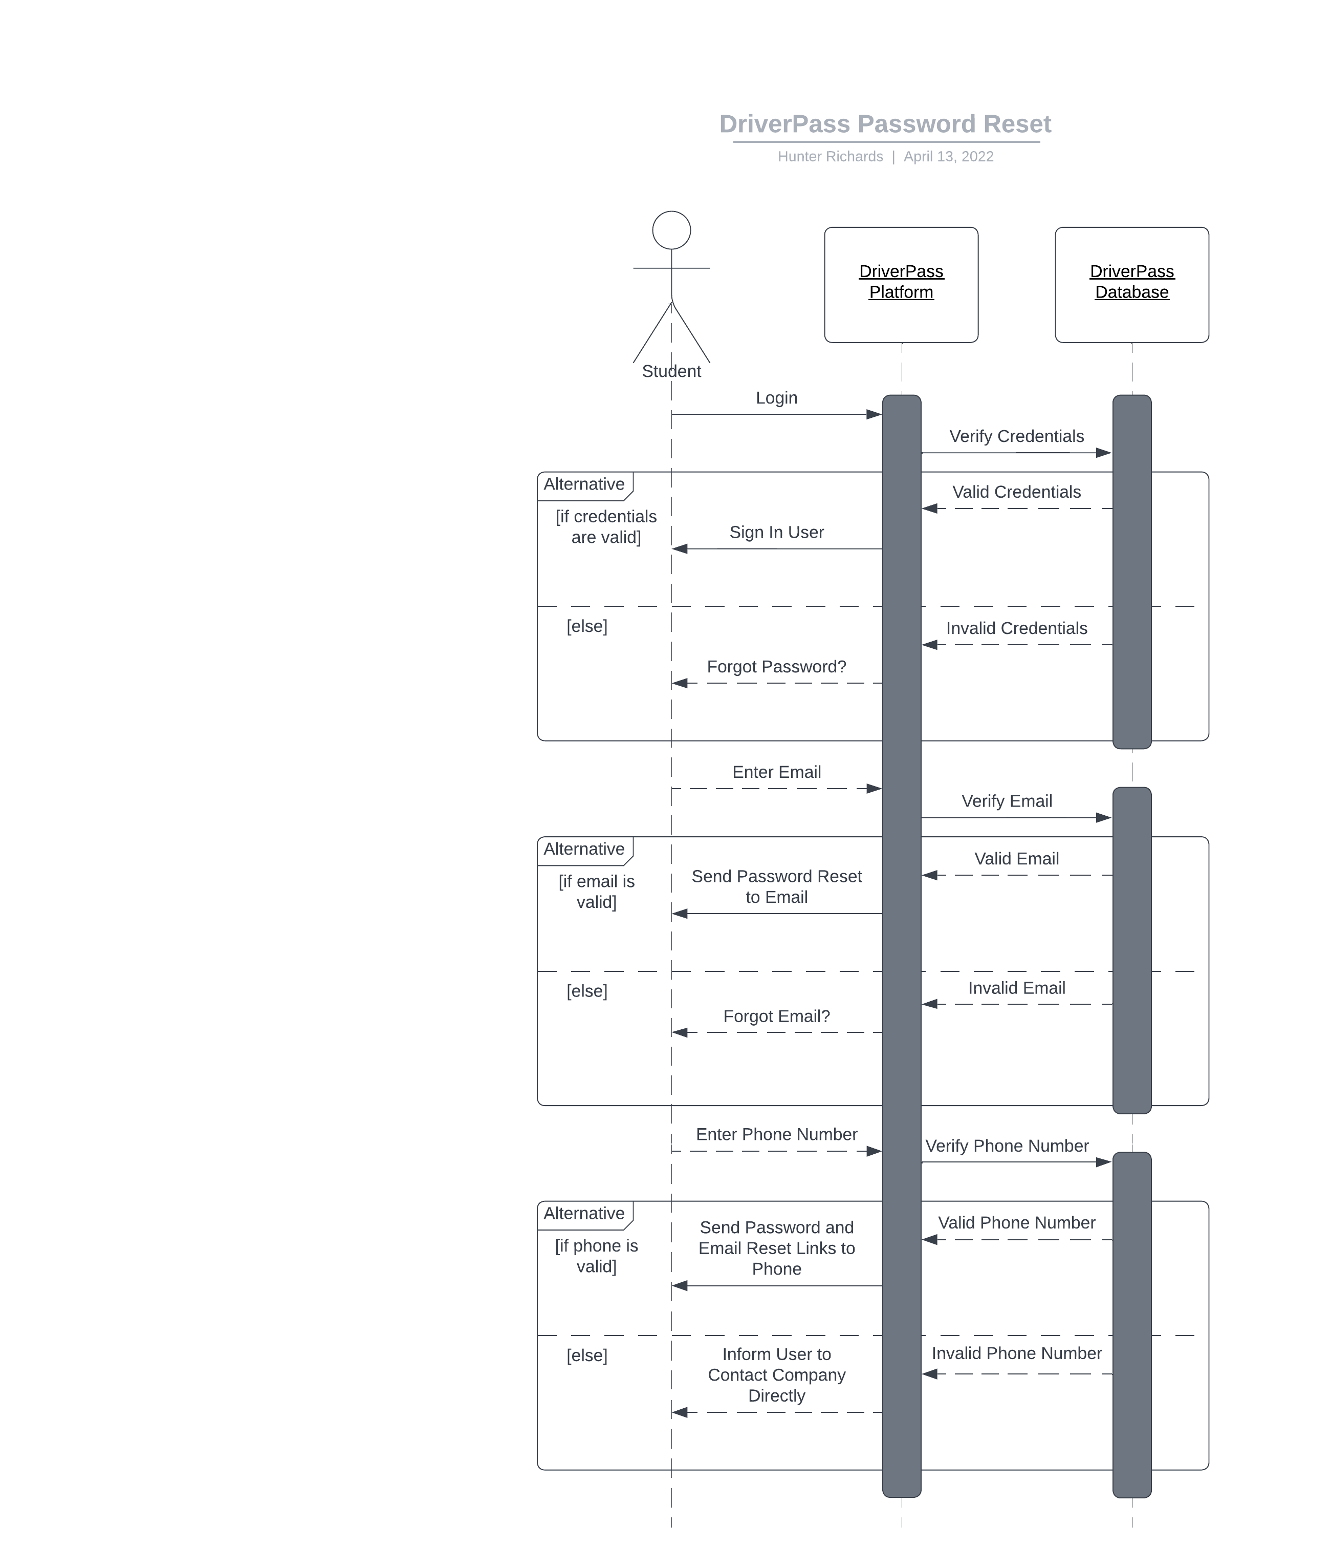

### UML Class Diagram

*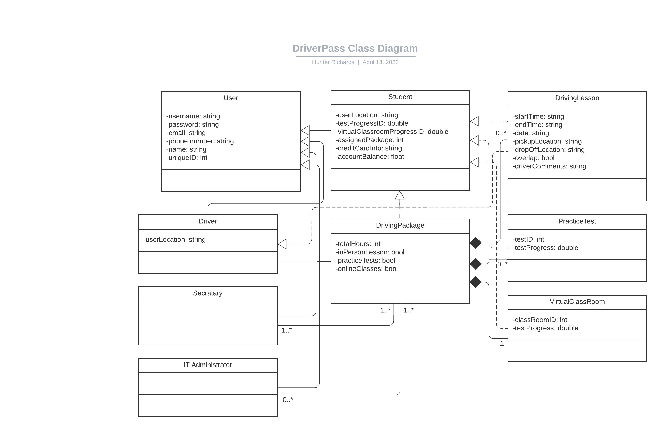*

## Technical Requirements

*[Based on the diagrams you have created, describe the technical requirements of your system. These requirements should address the required hardware, software, tools, and infrastructure necessary for your system design.]*

* *The DriverPass platform will need to operate using web-based protocols. This is to ensure wide coverage of various user devices and their applications.*
* *The web-based DriverPass platform will require an SSL certificate to ensure secure data transmission between the client and server.*
* *The DriverPass platform will require strong network speeds and connectivity, capable of handling hundreds of clients.*
* *The DriverPass platform will require very little operational down-time.*
* *The DriverPass system will require a cloud-based infrastructure solution (such as AWS) to host the DriverPass platform. A cloud-based solution requires little intervention and/or maintenance.*
* *The cloud-based solution will require expandable system resources to match client demands. (Rapid Elasticity)*
* *The system will require a database solution to store user data, data-logs, and sensitive personal information. The solution must be PCI DSS compliant.*
* *DriverPass IT Administrators will require a way to access the cloud-based solution (via an authentication method with some form of RDP/SSH/etc) to update and/or maintain the platform.*